PURCHASING POLICY

Town of Windham

PURPOSE. The purpose of this Purchasing Policy is to obtain the highest quality goods and services for the Town of Windham at the lowest possible price, to exercise financial control over the purchasing process, to clearly define authority for the purchasing function, to allow fair and equal opportunity among qualified suppliers, and to provide for increased public confidence in the procedures followed in public purchasing.

Ethics and conflict of Interest. Employees are expected to be impartial in carrying out their duties to assure fair competitive access to purchasing by qualified vendors. Gratuities or other favorable treatment, and the confidential use of information for personal gain are prohibited practices.

PURCHASE AUTHORIZATION. Purchases over $1,000 require approval of the Selectboard. When making any purchase not subject to the bid process described below, officers and employees must solicit quotes from at least two vendors and preferably three. Vendors will be selected based on cost, the quality of the goods and services offered, and the ability, capacity, and/or skill of the vendor demonstrated under prior contracts with the Town.

BID PROCESS. All purchases of $5,000 or more shall be subject to a bid process. The bid process shall be initiated by the issuance of a request for bids prepared by the Selectboard. Notice of the request for bids shall be made by letters to known providers soliciting bid responses, advertisements posted in three public locations within the Town. Advertisements placed in a newspaper of general circulation in the region will be at the discretion of the Selectboard due to the rural location of the town and the expense of advertising.

BID SPECIFICATIONS. Bid specifications shall include:

- Bidname.
- Bid submission deadline.
- Date, location, and time of bid opening.
- Specifications for the project or services including quantity, design, and performance features.
- Bond and/or insurance requirements.
- Any special requirements unique to the purchase.
- Delivery or completion date.

Once a request for bids has been issued, the bid specifications will be available for inspection at the Town office. When appropriate, the Select Board will hold a meeting to present specifications to potential bidders.

BID SUBMISSION. All bids must be submitted in sealed envelopes, addressed to the Town in care of the Selectboard, and plainly marked with the name of the bid. Bid proposals will be date marked on the outside of the envelope immediately upon receipt. Any bid may be withdrawn in writing prior to the scheduled time for the opening of bids. Any bids received after the time and date specified shall not be considered and shall be returned to the bidder unopened.

Bidders shall bid to specifications and any exceptions must be noted. A bidder submitting a bid thereby certifies that the bid is made in good faith without fraud, collusion, or connection of any kind with any other bidder for the same work, and that the bidder is competing solely on his/her behalf without connection with or obligation to any undisclosed person or firm.

BID OPENING. Every bid received will be opened and read aloud by the Selectboard at the first warned public meeting following the deadline. The bid opening will include the name and address of bidder; for lump sum contracts, the lump sum base bid; for unit price contracts, the unit price for each item and the total, if stated; and the nature and the amount of security furnished with the bid if required.

CRITERIA FOR BID SELECTION. In evaluating bids, the Selectboard will consider the following criteria:

- Price.
- Bidder's start date and anticipated end date.
- Bidder's experience and reputation, including past performance for the Town.
- Quality of the materials and services specified in the bid.
- Bidder's ability to meet other terms and conditions
- Bidder's financial responsibility.
- Bidder's availability to provide future service, maintenance, and support.
- Nature and size of bidder.
- Bidders Certificate of Insurance and any bond requirements.
- Any other factors that the Selectboard determines are relevant and appropriate in connection with a given project or service.

The Selectboard reserves the right at its sole discretion to reject any and all bids, wholly or in part, to waive any informalities or any irregularities therein, to accept any bid even though it may not be the lowest bid, to call for rebids, to negotiate with any bidder, and to make an award which in its sole and absolute judgment will best serve the Town's interest. The Selectboard reserves the right to investigate the financial responsibility of any bidder to determine his or her ability to assure service throughout the term of the contract.

CHANGE ORDERS. If specification changes are made prior to the close of the bid process, the Request For Bids will be amended and notice shall be sent to any bidder who already submitted a bid and a new bid process will be initiated. Once a bid has been accepted, if changes to the specifications become necessary, the Selectboard will prepare a change order specifying the scope of the change. Once approved, the contractor and an authorized agent of the Town must sign the change order.

EXCEPTIONS

Sole Source Purchases. If the selectboard determines that there is only one possible source for a proposed purchase, it may waive the bid process and authorize the purchase from the sole source.

Recurring Purchases. If the total value of a recurring purchase of a good or service is anticipated to exceed $2,500 during any fiscal year, every second year officers and employees will solicit quotes from at least two vendors and preferably three. Vendors will be selected based on cost, the quality of the goods and services offered and the ability, capacity, and skill of the vendor demonstrated under prior contracts with the Town.

Emergency Purchases. The Selectboard may authorize purchases for the purpose of meeting the public emergency without complying with the bid process. Emergency expenditures may include immediate repair or maintenance of roads, town property, vehicles, or equipment if the delay in such repair or maintenance would endanger persons or property or result in substantial impairment of the delivery of important Town services.

Professional Services. The bid process shall not apply to the selection of providers for services that are characterized by a high degree of professional judgment and discretion including legal, financial, auditing, risk management, and insurance services.

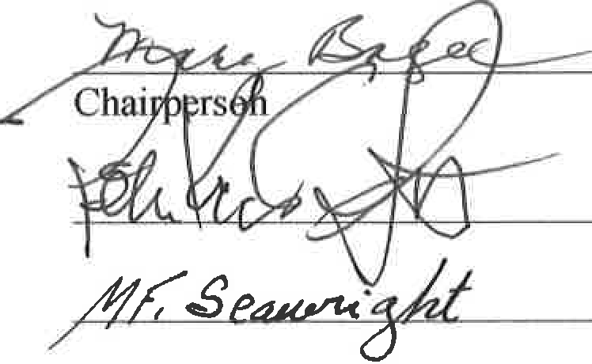
The foregoing Policy is hereby adopted by the Selectboard of the Town of Windham, Vermont, this 2 day of September, 2014 and is effective as of this date until amended or repealed.

