Tuesday, 9 October 2018   5:30 PM

The WCC’s monthly meeting was held at the outfall of Burbee Pond to inspect the “beaver deceiver” constructed and installed by Skip Lisle of Grafton and to discuss with Vermont DEC natural resources biologist Josh Mulhollem the general Burbee Pond habitat, pond evolution, wildlife, etc.   Beaver and heron activities were observed during the site visit.   The relative absence of customary beaver “food” - aspen/poplar saplings - was also observed.  Any resident with a surplus of such sapling  growth is encouraged to contact pond homeowner Dawn Bower re donating material for  use by the resident beaver population.

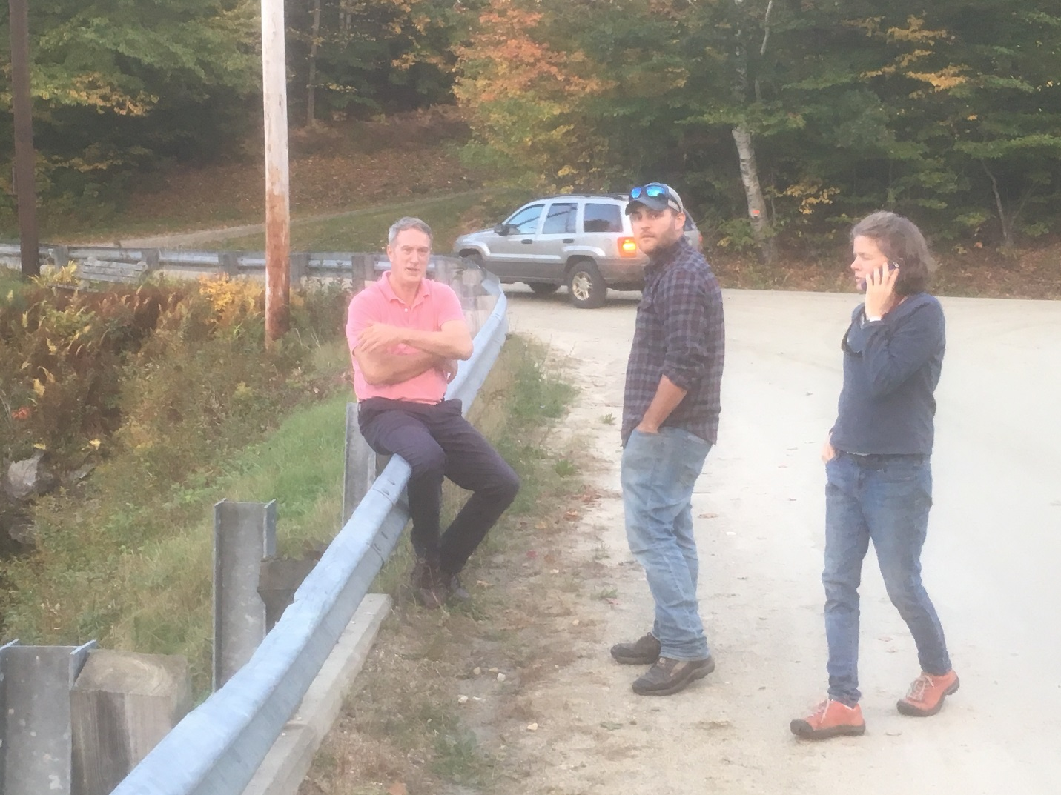

_

L > R    Skip Lisle, Josh Mulhollem, Alison Trowbridge