TOWN OF WINDHAM
DRAFT ENHANCED ENERGY ELEMENT
1/22/2018

Windham Regional Commission’s
Act 174Technical Assistance to Municipalities

Note: In addition to drafting this energy element, the remainder of the town plan needs to be examined so as to be consistent with the policies proposed in this energy element. For Act 174 standards compliance, the entire town plan will be checked and cross-referenced for policy consistency. Also, this should be of importance to planners in the context of how the plan would be used in the Section 248 process, which references “land conservation measures and specific policies.”

Importance of Enhanced Energy Planning

Introduction

Energy planning is important to Windham and its residents, since the Town is located at the highest elevation in of all towns in Vermont, and our Town is rich in resources, natural beauty, and history. We realize the importance of protecting our environment and to cherish and protect these resources for the future. Windham is and will continue to be, very pro-active in the process of the State energy goals, as outlined in the 2016 Comprehensive Energy Plan, by continuing to enhance opportunities to create renewable energy sites, construction which encourages green development, promote transportation opportunities for carpooling and innovative vehicles, and availability to educate our residents in energy conservation. Though Vermont’s energy transformation may take years to implement, it will enhance the vitality of the state and local economy by reducing money spent on fuels pumped, mined or generated elsewhere, improve our health through reduced emissions and increased bicycle and pedestrian mobility options, and improve the quality of our local and global environment through reduced greenhouse gas emissions. This robust energy plan is used as a tool to advance the economic and environmental well-being of Windham, thereby improving the quality of life for its residents. Furthermore, these energy goals will reduce Windham’s vulnerability to energy-related economic pressures and, in the long-term, climate change-related natural disasters, and promote long-term community resiliency in a variety of contexts.

The estimated energy consumption in Windham, including residential, commercial and governmental use (for heating, electricity, transportation, etc.) is estimated to be $2,542,815 per year (see Energy Costs & Expenditures section below for a break-down of this figure). Because a large majority of this energy is imported from outside the town and Windham Region, most of the money spent on energy does not directly benefit the local economy. Efforts to reduce the use of energy sources from outside the Town as well as shift reliance to locally produced energy can improve household financial security and strengthen the local economy.

From an environmental perspective, petroleum and other hydrocarbon-dependent energy is a significant cause of localized environmental damage where those fuels are produced and refined, and the emissions from their use is responsible for human-induced climate change, related climate-change disasters, and ecological degradation. Any efforts to reduce the use of non-renewable energy and shift to more environmentally-sound energy sources will benefit the town’s environment. by _(some town-specific examples)_______.

While Windham can do little to shift the broader state or federal policies, we can influence energy use and production on a local level. In this energy plan, we hope to address Windham’s local actions for increasing our energy efficiency and promoting renewable energy generation, and overall pathways to become more resilient.

Long-Term Vision & Petroleum Dependence

There is a trend toward factoring the “societal costs” into the price of energy; society pays for health costs associated with pollution, environmental clean-up, military protection of petroleum sources, and the continued failure of the Federal government to address the disposal of radioactive wastes. And in the long-term, communities who depend on fossil-fuels are vulnerable to risks associated with their price and production volatility.

These challenges may significantly increase the cost of conventional energy sources within the next ten to twenty years. As a result, Windham will seek to establish reliable energy resources for townspeople and municipal operations, to hedge against the increasing volatility of hydrocarbon prices, and to reduce the environmental impact of our energy use. The role of clean, alternative energy sources will be expanded and supported.

2. Windham’s Current Energy Use

The following paragraphs describe Windham’s current estimated energy demand in detail. These current use estimations provide a starting point from which the town can develop informed energy policies that directly address its current context and opportunities going forward.

In order to provide a more accurate picture of the energy planning requirements in Windham, energy consumption, generation targets, and efficiency targets need to be broken down into three distinct energy sectors. Those sectors are electricity, transportation, and heating.

Figure 1 shows how energy consumed in the town is divided between these sectors. The sections below break down the calculations and describe the assumptions made to arrive at these final demand figures.

Chart 1: Annual estimated energy consumption across three sectors.

Windham’s Current Electricity Demand

Windham’s electric energy supply comes from Green Mountain Power. In 2013, GMP projected multiple sources of purchased electricity to cover the State’s needs.

Electricity consumption data from Efficiency Vermont was produced for each zip code in the state, and is the primary source of this information. This data set combines the energy supplied from all potential electricity providers to that town. It also separates the usage for both the residential and commercial or industrial sectors in zip code area 05359, which includes the towns of Windham and West Townshend (see Figure 2 below).

Chart 2: Electric Use in Windham (05359) per Sector

To translate this energy demand into dollar amounts, we can estimate a cost of $0.1435 per kilowatt-hour (Vermont state average for electricity costs across all sectors in 2015). Based on the above data, residences in town paid almost $982,767.36 dollars in 2014 for 6,848,553 kWh. Commercial facilities paid just over $567,835.24 dollars for their 3,957,040 kWh of electricity. In Windham, electricity usage places the highest energy cost burden on its homeowners and businesses.

Windham’s Current Transportation Use

According to 2010 U.S. Census Bureau data, Windham has 167 primary housing units, (not vacant or used for seasonal/recreational purposes). Based on that number of households, it can be estimated that there are 321 vehicles on Windham’s roads, which consume 684 gallons per vehicle of fossil fuel each year. To get this gallon/year rate, you multiple the number of vehicles (22,290) by estimated vehicle miles traveled (12,500) divided by average fuel economy (22) and remove 9% of usage because of ethanol in gasoline. Below is a table summarizing the averages and estimates used to arrive at the values.

167 | Number of primary housing units.
321 | Number of fossil-fuel burning light-duty vehicles (LDV).
12,500 | Estimate of the average annual number of miles travelled by an LDV in the area (for Vermont as a whole, total vehicle miles traveled per registered vehicle was around 12,500. The vast majority of LDV in Vermont can safely be assumed to drive between 9,000 and 15,000 miles annually).
22 | Estimate of the average fuel economy of fossil-fuel burning LDV fleet in the area, in miles per gallon (state-wide average fuel economy).
166,012 | Estimated number of gallons of fossil fuel consumed annually, calculated from the values above less the 9% ethanol.
121,259 | Number of Btu in a gallon of fossil fuel, computed as a weighted average of the individual heat contents of gasoline (95%) and diesel (5%).
21,521 | This is the estimated total annual energy consumption of internal combustion vehicles in the area, in millions of Btu.

Table 1: Transportation Energy Consumption

To estimate the cost of this consumed energy, we assumed a cost of $2.34 per gallon (Vermont state average in 2015). In Windham, consumers spent over $388,984 on transportation related fuel costs alone.

Current Heating Demand

To account for the different building types and their respective uses, the following estimates divide thermal energy demand by either residential or commercial use (industrial building thermal demand is not included).

For residential buildings, it was assumed that average annual heating load of area residences is 110 million Btu, for both space and water heating (Vermont state average). With 167 primary housing units in the town, this arrives at an estimated 20,570 MMBtu annual total heat consumption.

Furthermore, census data also provides information on the home heating fuels used for both owner-occupied and renter-occupied housing units (both are considered “occupied”). Figure 3 below shows a comparison of owner and renter-occupied housing units and their respective fuel use.

For both housing unit ownerships, an estimated total of just over $468,476 was spent in home heating (roughly $439,267 from home owners and $29,210 from renters).

Chart 3: Home Heating Fuel Type

In Windham, there is also a high percentage of seasonal homes (47% of housing units are primary/“occupied” homes, while 53% are seasonal/“vacant” homes). Based on the energy model projections from the state (created by the LEAP, or Long-Range Energy Alternatives Planning model), it can be assumed that seasonal homes only use about 15% of the energy of a primary home, due to more occasional use and a presumed higher energy efficiency. As such, seasonal homes in town are estimated to consume about 3,479 MMBtu annually (compared to the 20,570 MMBtu for primary residences).

For commercial establishments, it is estimated that the total heating load is 2,984 MMBtu each year. For the state, the average is in the range of 700 MMBtu to 750 MMBtu per year but the average for any given area is very likely to be significantly higher or lower, as the mix of businesses from region to region is highly variable. Based on the types of commercial buildings in Windham, the heating load was calculated to be less than state average. With 6 commercial establishments, there is an estimated thermal energy demand of 497 MMBtu. These businesses pay about $134,803 each year in heating expenses.???

Total Energy Costs

In summary, Windham pays a staggering amount in energy across the three use sectors. The total estimated cost to the town for electricity, heating, and transportation is roughly $2,542,815 each year. There are real financial incentives for the town to move toward energy efficiency, on behalf of both the residents and its business owners (see section “4. Energy Scarcities, Challenges, and Strategies” of this plan for more detail about energy efficiency and conversion targets).

Figure 4: Annual Energy Expenditures

3. Windham’s Resources, Constraints, & Potential for Energy Generation

Available energy resources within Windham are all renewable resources: wood, solar, hydro, and wind. In order to reduce dependence on conventional energy sources, of which the costs and availability are outside residents’ control (see the section above), the use and generation of alternative energy sources is encouraged.

Resource Mapping Process and Policy Tool

The suite of maps included with this Enhanced Energy Element were developed using state-wide GIS data that modeled resource potential for solar and wind energy, identified potential constraints on renewable energy development, and created an energy potential map.

This energy potential map provides energy planners and developers with a “coarse screen” method to roughly identify areas in Windham that may have energy generation potential. These maps are not siting maps, and further site analysis would need to be done to determine if a proposed generation facility is appropriate and comports with Windham’s Town Plan policies. Instead, these maps provide Windham planners with tools to develop sound and informed energy generation policies within this Enhanced Energy Element.

Solar Resource Maps

The solar resource maps for Windham show a significant available solar resource, with some overlap with constrained areas such as wetlands. The Town supports solar facilities that are properly sited, where the development conforms to the siting policies outlined in this Town Plan. Refer to the “Energy Goals, Policies, and Action Steps” section below for policy statements regarding solar generation

Wind Resource Maps

The wind resource maps for Windham show large areas of wind energy potential, however with significant overlap with constrained areas. The Windham Town Plan explicitly prohibits Commercial/Industrial wind facilities as described in detail in the Plan. Individual small-scale wind installations are a permitted use in all zoning districts within Windham except for the Hamlet and Historic districts. Refer to the “Energy Goals, Policies, and Action Steps” section below for policy statements regarding wind generation

Windham’s Preferred Locations

The Town of Windham supports residential and community scale renewable energy generation facilities in a manner that comports with existing and proposed land use designations, does not adversely affect the landscape pattern or character of the Town, and supports positive community development. Generally, the Town promotes energy generation development in locations that are previously disturbed and do not offer significant opportunities for future development. These areas may include former gravel pits, mines, or quarries, landfills, etc. Existing areas of open land such that significant deforestation would not be required are also preferred. Extra consideration should be given to these under-utilized and previously disturbed areas that exist within the areas modeled to have prime resource potential (see Energy Maps), and do not conflict with existing and proposed designated land uses. Refer to the “Energy Goals, Policies, and Action Steps” section below for policy statements regarding preferred generation sites.

Existing Renewable Energy Generation

Areas Unsuitable for Renewable Energy Siting

As shown in the Known Constraints map, there is a suite of geographic characteristic that are deemed to exclude any energy generation development. They are mapped vernal pools, Class 1 and 2 wetlands, DEC River Corridors and/or FEMA floodways, and State-significant Natural Communities and Rare, Threatened, and Endangered species.

The Possible Constraints are a set of data layers that don’t necessarily exclude energy development but give a signal to potential developers and planners that more site analysis may be required. These layers include hydric soils, FEMA Special Flood Hazard Areas, Protected lands, deer wintering areas, Vermont Conservation design highest priority forest blocks, and agricultural soils. If generation facilities are proposed in these areas, due diligence is required in the siting of those facilities to ensure there are no adverse effects on the landscape.

Aside from these state-identified constraints, the Town of Windham has determined that energy generation facilities are generally not compatible with the Resource Overlay Districts outlined in the Land Use chapter of the Windham Town Plan, and include Resource Conservation and Flood Hazard Overlays. These areas are delineated as containing fragile natural areas that should be protected.

Similarly, energy generation within the Hamlets and Historic Districts should be very carefully sited so as not to conflict with the policies outlined within those land use districts.

4. Windham’s Energy Targets and Conservation Challenges

The Windham region was given an overall renewable energy generation target, as determined by the Department of Public Service, based on its percentage of the state’s population (which directly affects its share of statewide consumption). The Windham Regional Commission (WRC) then determined energy generation targets for each of their member-towns, based on both the resource availability in town and its population. The resulting town generation targets are an average between those two characteristics. The resulting town generation targets are an average between those two variables.

Table 2 below shows the targeted percentage of consumed fuel sourced from renewable energy, across the three consumption sectors. This is in line with Vermont’s renewable energy goals outlined in the 2016 Comprehensive Energy Plan.

Use of Renewable Energy
Sector |  | 2025 | 2035 | 2050
Transportation (as a percentage of total Btu's consumed) |  | 10% | 31% | 90%
Heating (as a percentage of total Btu's consumed) |  | 56% | 67% | 93%
Electricity (MWh to be generated in town) | See the “Energy Generation Targets" section below.
The data above shows targets for the percentage of energy use coming from renewable sources for each sector at each target year. This was developed using information from the LEAP analysis (see sections below).

Table 2: Percentage use of renewable energy.

Energy Generation Targets

In Windham, it is estimated that 695 MWh of new renewable energy should be generated each year. This figure is an average of 458 MWh (based on the town’s share of the regional population), and 933 MWh (based on the percent of regional resource availability). This estimated generation target serves as a starting point from which the town can develop policy to address its energy needs.

To translate this figure into what kinds of installations would be required, 695 MWh of renewable energy each year would require a total of 535 kilowatts of solar photovoltaic installations (using the assumption that only solar energy would contribute to the overall energy generation target, not any other generations source).

Windham’s Energy Generation Targets at Benchmark Years
This is the target amount of renewable energy generation in town by 2025 (25% renewables goal), in MWh. | 193
This is the target amount of renewable energy generation in town by 2035 (40% renewables goal), in MWh. | 309
This is the target amount of renewable energy generation in town by 2050 (90% renewables goal), in MWh. | 695

Table 3: Renewable energy generation targets at 2025, 2035, and 2050.

Acres Available in Municipality for Energy Generation
Total number of acres in town (from GIS analysis). | 16,751
Total number of acres available for prime solar (with no state or local constraints). | 589
Total number of acres available for residential wind (with no state or local constraints). | 1,395
Total number of acres available for small commercial wind (with no state or local constraints). | 832
Total number of acres available for utility wind (with no state or local constraints). | 98

Table 4: Acres of available resource potential for different generation technologies.

Acres Needed for Municipal Energy Generation
This is the estimated number of acres of land needed for solar installations to meet municipal targets. | 4
This is the amount of land that should be identified in plans for solar installations (as a planning contingency). | 32
For estimated solar generation, this is the percentage of land in town needed for installations (not accounting for potential rooftop solar). | 0.03%
For estimated solar generation, this is the percentage of acres identified as prime solar resource needed in town for installations (not accounting for  potential rooftop solar). | 0.73%
This is the estimated percentage of the municipal target that can be met by rooftop solar on existing structures. | 35%
This is the estimated amount of energy that can be generated from rooftop solar annually, in MWh. | 241

Table 5: Acres needed for Windham to meet generation target.

On the landscape, this could mean that the town identifies 32 acres of solar-capable land. This is a very conservative figure; assuming that each mega-watt of energy requires 60 acres (on average, solar installations produce a single mega-watt over 8 acres equating to 4 acres of actual installations). Using the 60 acres/megawatt energy production rate is for contingency; meaning that it reserves space for landowner, grid, or spatial constraints that may limit development. This ensures enough space would be delineated.

The tables also show that, in addition to demonstrating that only 0.73% of the modeled prime solar resource potential land area is needed for energy generation, it is estimated that about 35% of Windham’s renewables target can be met by rooftop solar installations on existing structures. This will lead towards the Town incentivizing these types of installations, so as to minimize the amount of land area in town used for ground-mounted photovoltaic generation facilities.

If other renewable energy sources were to be used, this amount of solar photovoltaic installations would decrease.

Although renewable energy generation can occur in the town and supply its residents with reliable, affordable, and clean power, the town is challenged by the current amount of energy being consumed. In order to minimize the amount of energy generation required, the town must first develop strategies to reduce the amount of energy consumed.

Projected Energy Use: LEAP Model Results

To help inform the town’s policies on energy conservation measures, the town used guidance from the LEAP (Long-Range Energy Alternatives Planning system) model, conducted by the Vermont Energy Investment Corporation as part of the state’s comprehensive energy planning initiative.

The LEAP model is used to guide the state’s regions towards reducing the amount of greenhouse gas emissions and consuming 90% renewable energy by 2050 (referred to as the “90x50” goal). To accomplish the state’s energy goals, there are several interim benchmarks built into the LEAP model which ensure a progressive pace in attaining that “90 x 50” goal. The state energy goals are:
- Greenhouse gas reduction goals of 50% from 1990 levels by 2028 and 75% by 2050.
- 25% of energy supplied by renewable resources by 2025 (25 x 25).
- Building efficiency of 25% of homes (80,000 units) by 2020.

Incorporating those goals into the model produced energy generation, conservation, and fuel conversion targets for benchmark dates for all regions in the state, and is informed by the region’s current energy profile. The WRC received the results from this model and was tasked with making those results relevant to its member-towns. The WRC therefore divided its region-wide benchmark targets among its towns based on their population (which is assumed to most directly impact the amount of energy the towns consume).

The following paragraphs, tables and charts show Windham’s LEAP model results, and how much energy could be conserved in order to reduce the burden of energy generation facilities in the region.

Residential Heating Conservation & Fuel Conversion

In order to determine how much energy would have to be conserved or how much fuel conversion to renewable energy, the LEAP model produced both a “Reference” and “90x50” scenarios. The Reference scenario is meant to depict energy use over decades if no major changes were made in our energy profile. It is the “business as usual” scenario. The “90x50” scenario shows one pathway that communities can adopt in order to reduce greenhouse gas emissions, conserve energy, and generate renewable energy so as to meet the state’s goals. This pathway is translated to Windham’s use, and is shown below. It is another data estimate that serves to help inform the town to develop its own policies for energy conservation and fuel conversion.

Chart 4 below shows the LEAP results for Windham’s residential heating sector. In both the Reference and 90x50 scenarios, energy consumption is modeled to decrease (on account of technological improvements, building innovation, and home efficiency improvements).

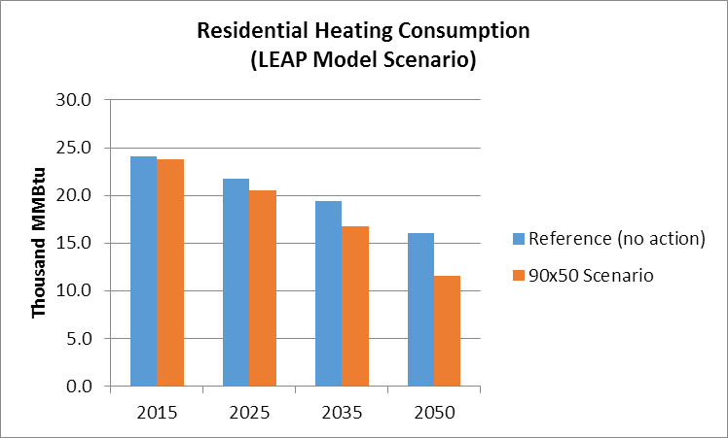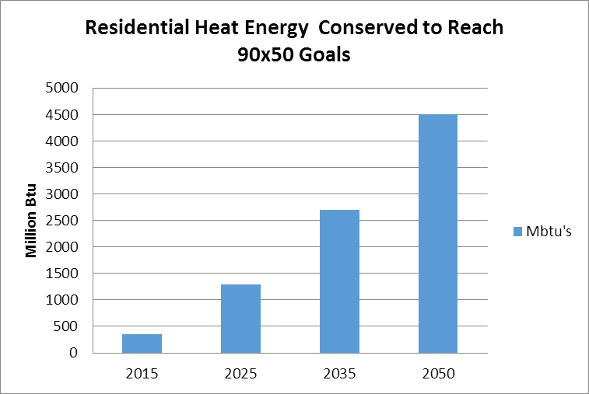

Chart 5 Chart 6

However, the 90x50 scenario shows a sharper increase in the amount of energy conserved in residential heating. Chart 6 shows how much energy should be conserved, through 2025, 2035, and 2050, to help the town arrive at these energy goals. Not only would energy need to be solely conserved by building efficiency measures, but fuel conversion to more efficient energy sources would be promoted.

To translate the above bar graphs into more meaningful and tangible data points for the Town, some estimates were made that provide a pathway to more energy conservation and efficiency over the target
years of 2025, 2035, and 2050. Below in Table 6 is outlining the heating (or, “thermal”) efficiencies and building weatherization targets that could be made in Windham to meet these targets.

In order to attain the renewable energy goals, the following targets have been established for Windham for years 2025, 2035, and 2050.

Thermal (Heat) Efficiency Targets at Benchmark Years
Use/Sector | 2025 |  | 2035 | 2050
Residential thermal (increased efficiency and conservation): Percent of municipal households to be weatherized over benchmark years to meet efficiency targets. | 9% |  | 18% | 37%
Residential thermal (increased efficiency and conservation): Estimated number of municipal households to be weatherized. | 37 | 72 |  | 148
Commercial thermal (increased efficiency and conservation): Percent of commercial establishments to be weatherized over  benchmark years to meet efficiency targets. | 9% | 16% |  | 30%
Commercial thermal (increased efficiency and conservation): Estimated number of commercial establishments to be  weatherized. | 1 | 2 |  | 4

Table 6: Heat Efficiency Targets

The following Table 7 shows what kind of fuel conversions, for both residential and commercial buildings, could be made to meet the proposed targets. This also includes the increased use of new heat pumps.

Heating Fuel Switching Targets
Use/Sector | 2025 | 2035 | 2050
Residential and Commercial Thermal Fuel:  Estimated new efficient wood heat systems overall (in units) in the LEAP 90x50 scenario (this includes both wood stoves and wood pellet burners for homes and businesses).  This number may decline over the target years, which indicates an overall trend toward energy conversation and building weatherizing, which reduces the demand on heating systems. | 110 | 105 | 105
Residential and Commercial Thermal Fuel:  Estimated new wood pellet systems only (in units) in the LEAP 90x50 scenario. | 19 | 21 | 26
Residential and Thermal Fuel: Estimated new heat pumps (in units). | 34 | 67 | 95
Percent of heating fuel sourced by renewable energy. | 56 | 67 | 93

Table 7: Heating Fuel Targets

(Insert here more information about charts Add Text about following charts)
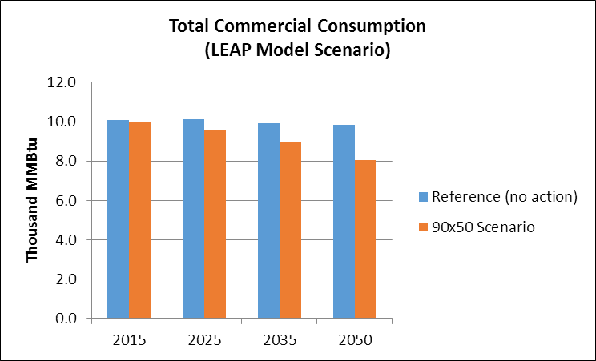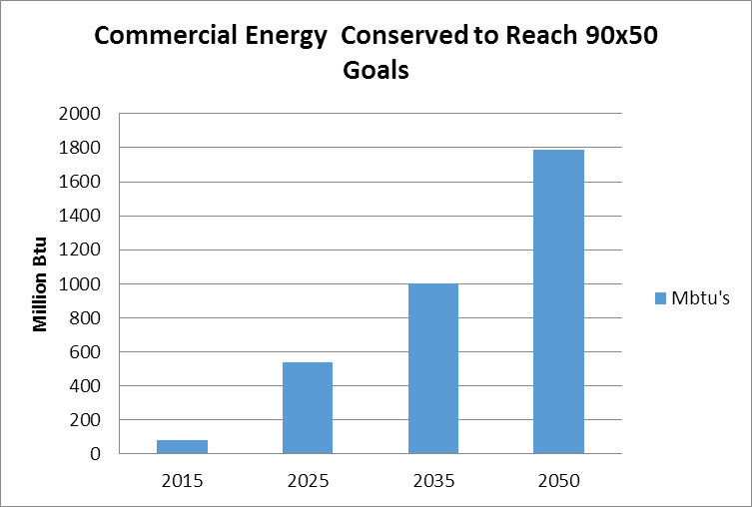

Chart 7 Chart 8

Transportation System Changes

The LEAP model created benchmark targets for both light and heavy-duty vehicles, assuming a difference in residential and commercial energy needs and changes over time. Below in Charts 9-12 are the two interpretations of these sector’s efficiencies over time.

Chart 9 Chart 10

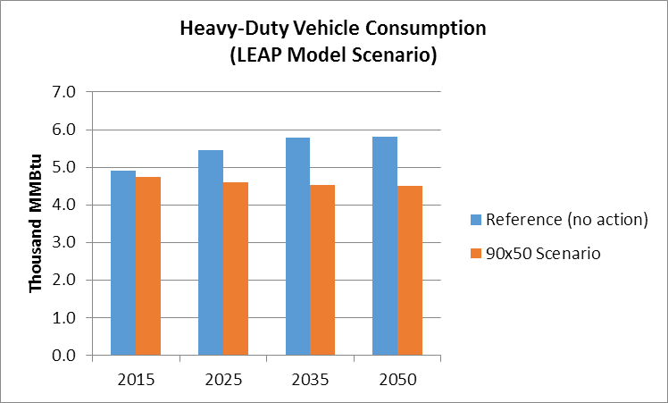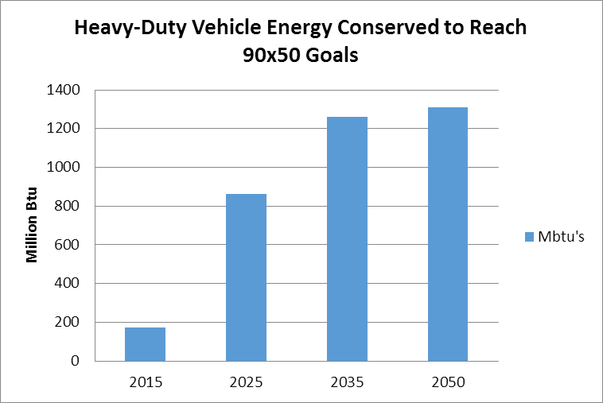

Chart 11 Chart 12

Light-duty vehicle consumption represents a larger portion of the total amount of energy consumed by the transportation sector, and there is a large amount of energy conservation required. The LEAP model projects much of this conservation of energy comes from the electrification of the vehicle fleet, especially as market demand changes and technology improves. This reduction in gasoline consumption and electrification of the car motor comes in addition to increased cluster developments and other land use changes that improve the efficiency of our community’s transportation network.

Transportation Fuel Switching Targets
Use/Sector | 2025 | 2035 | 2050
Transportation Fuel:  Estimated number of new electric vehicles, in town. | 24 | 166 | 351
Transportation Fuel:  Estimated number of biodiesel-powered vehicles, in town. | 36 | 69 | 119
Percentage Fuel sourced by renewable energy  In the target years. | 10 | 31 | 90

Table 8: Fuel switching targets for the transportation sector, across the benchmark years.

Heavy-duty vehicle consumption doesn’t show the same curves as per light-duty vehicles, since commercial applications for these vehicles isn’t anticipated to change as much. However, efficiency in this sector is achieved by changing the fuel type for these vehicles from diesel to bio-diesel.

Electricity Conservation

Over the benchmark years, electricity rates are anticipated to increase in the Reference scenario, due to a combination of more amenities, appliances, and motors being supplied by electric power, and an increase in the number of people using those products. The 90x50 scenario promotes electricity conservation in the form of energy-efficient appliances, lighting, and heating/cooling.

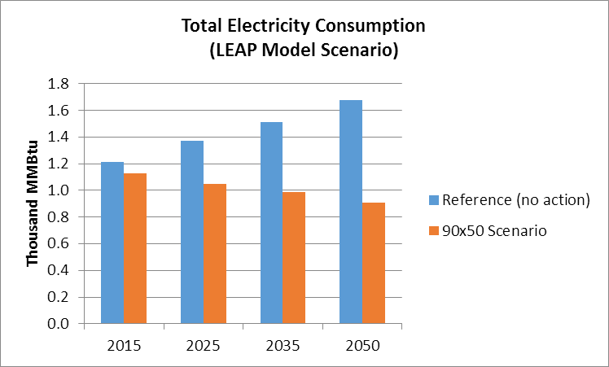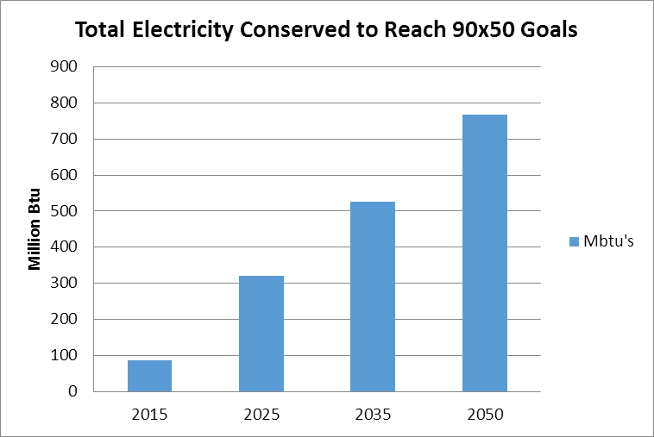

Chart 13 Chart 14

Efficiency Targets at Benchmark Years
Use/Sector | 2025 | 2035 | 2050
Electricity:  Number of kilo-watt hours to be conserved, annually, over the target years. | 742,100 | 1,212,700 | 1,773,800
Electricity:  Percentage of number of homes and buildings  that will have been upgraded with electric efficiency improvements. | 42% | 68% | 100%

Table 9: Electric-sector efficiency targets across the benchmark years.

Conservation and Efficiency Strategies

With total energy expenditures in the town in excess of $2,542,815 per year there is considerable opportunity for savings from various energy conservation and improved efficiency measures. Because most of the energy use in Windham is for private uses (home heating, commuting, electric), savings would accrue primarily to residents. Public education is one of the most effective strategies to bring about savings through energy conservation and improved efficiency, though there are some specific policies that can also move the community in that direction.

Most new construction in Windham is required to meet or exceed the Vermont Building Energy Standards (for both residential and commercial buildings) through the use of insulation, heating systems, and weatherproof windows and doors. Current building codes provide basic energy efficiency requirements for buildings; however, technology advancements have generated higher standards such as net-zero energy construction standards in which buildings generate as much energy as they consume. Green construction and LEED Construction (Leadership in Energy and Environmental Design) standards promote the use of natural, recycled and durable building materials, as well as energy efficiency. These efficiency standards are also applied to landscaping, advocating for native plantings that are low maintenance.

The siting, design, and construction of buildings strongly influences the amount of energy needed for heating as well as the amount of electricity needed for lighting. Proper subdivision design, building orientation, construction and landscaping provide opportunities for energy conservation such as less vehicular travel, and by designs incorporating passive solar space and domestic hot water heating, natural lighting and photovoltaic electricity production.

Energy savings can be realized by retrofitting existing buildings with insulation, installing high-performance windows and doors to reduce heat loss, weather-stripping, replacing incandescent lights with fluorescent, and using energy efficient appliances. The following programs are available to residents of Windham:

- Southeastern Vermont Community Action (SEVCA): SEVCA is the service provider in Windham County that runs the Weatherization Assistance Program. Weatherization services, which include an energy audit, diagnostic tests, analysis and installation measures, are available at no cost to income-eligible homeowners and renters. SEVCA is also available to help in the event of a heating emergency. They can help purchase oil, kerosene, propane or wood. In addition, they also work with electric companies in order to prevent disconnection and help negotiate payment plans.

- Efficiency Vermont: Efficiency Vermont is the State’s provider of energy efficiency services. They provide technical and financial assistance to electrical consumers for the purpose of improving the efficiency of existing and new facilities.

- ENERGY STAR Home Rebates: Energy Star Homes meet strict energy efficiency guidelines set by the U.S. Environmental Protection Agency and U.S. Department of Energy. Efficiency Vermont provides free financial, design, and technical to help build an ENERGY STAR qualified home. Benefits of being an ENERGY STAR home include financial incentives such as product rebates; utility savings; higher resale value; increased comfort and air quality; and other environmental benefits.

- Vermont Housing Finance Authority’s Energy Saver Loan Program: Administered by Windham Housing Trust, this program offers low interest loan funding for homeowners for an energy audit and improvements specified in the audit.

Transportation-related efficiency strategies are a very significant part of Windham’s efforts, since it represents a significant portion of the energy demand. Simple changes, such as ride-sharing, combining trips and using alternative transportation, will conserve fuel and reduce wear and tear and maintenance costs on individual vehicles. Fuel efficient and electric cars will use less gasoline and emit less pollution.

Effective land use planning can promote energy conservation. Targeting new development toward areas located close to the community's major roads and existing settlements will minimize the energy consumed by residents commuting, and will reduce the energy required to deliver essential services to residents and businesses.

5. Energy Goals, Policies, and Action Steps

Goal 1: The Town of Windham will reduce total energy use by promoting energy conservation and efficiency measures and a shift toward renewable energy sources.
Policy 1.1: Encourage energy efficiency and conservation, and renewable energy generation by individuals and organizations through public education, awareness, and engagement.
Action Steps:
- The Energy Committee will organize at least one energy fair each year which will provide information to the public about efficiency, conservation and renewable sources of energy, as well as access to one or more vendors who offer services in those areas.

- The Energy Coordinator and/or Energy Committee will provide information in the Town Office about energy assistance programs such as SEVCA and Efficiency Vermont.

- The Energy Committee will post the minutes of all of its meetings on the town website.

- The Energy Committee will occasionally publish information about energy efficiency, conservation and renewable energy in the Windham News & Notes.

- The Energy Committee, when appropriate, will organize public information sessions about alternative energy sources, such as community solar projects.
Policy 1.2: Promote energy efficiency in new and existing buildings by supporting programs for insulation and weatherization, especially for low and moderate-income households.
Action Steps:
- The Town will provide information about resources for building energy efficient homes and businesses, including The Vermont Residential and Commercial Building Energy Codes and LEED (Leadership in Energy and Environmental Design) standards.

- The Town shall develop guidelines for energy conservation to be used in site plan or conditional use review. Whenever possible, development should be encouraged only in areas with characteristics most suitable for maximum energy conservation, including southern orientation and protective wind barriers.

- Review current zoning bylaws to determine whether existing standards related to energy conservation and energy efficient site design and building construction are adequate. Revise, as necessary, to require optimum feasible energy reduction and efficiency.

- Explore the creation of residential and commercial building efficiency ratings and ways to reward those who achieve the highest ratings.
Policy 1.3: Encourage the awareness and use of programs that decrease the use of fossil fuels for heating and promote the use of alternative and renewable fuels.
Action Steps:
- Provide information to residents about programs and technologies that decrease dependence on fossil fuels for heating, including the Windham Wood Heat Initiative, geothermal energy, solar energy, small scale wind turbines, cold climate heat pumps, etc.

- Promote the use of energy efficient light bulbs.

- Promote awareness of the benefits of passive solar heating and enhanced insulation as effective tools for reducing the use of fossil fuels.

Policy 1.4: Demonstrate town leadership by making a commitment to energy conservation in the operation of municipal building, facilities and vehicles.
Action Steps:
- Continue, as needed, energy audits of municipal buildings and publicize the results of the audits.

- Develop facility maintenance and operation policies that maximize energy efficiency while maintaining comfort levels for employees and visitors. The policies could include building heating and air conditioning temperature guidelines, electrical equipment use guidelines, interior and exterior lighting guidelines, and the use of energy management devices, such as programmable thermostats, occupancy light sensors, smart strips and energy star appliances.

- Continue, as needed, to improve lighting efficiency by retrofitting municipal buildings with energy efficient compact fluorescent or LED bulbs and fixtures, with the assistance of Efficiency Vermont and/or local utilities.

- Investigate the use of the town web page and appropriate software programs to promote carpooling.

- Develop municipal vehicle purchase, maintenance and use policies, including minimum fuel efficiency standards for new vehicles. Consider alternative-fuel vehicles as available and appropriate.

Goal 2: The Town of Windham will work to reduce transportation energy demand and single-occupancy vehicle use and encouraging use of renewable or lower-emission energy sources for transportation. Windham supports ongoing and collective efforts to reduce transportation energy demand, vehicle miles traveled, fossil fuel consumption and greenhouse gas emissions.
Policy 2.1: Encourage the increased use of public transit.
Action Steps:
- Involve public transit companies and other providers in the Windham Town Energy Fairs.

- Provide appropriate areas for public transit pickup.

- Encourage public transit companies to provide routes near to Town.

Policy 2.2: Promotes a shift away from single-occupancy vehicle trips.
Action Steps:
1. Examine feasibility of creating park-and-ride facilities on Route 11 and Windham Hill Road in South Windham.
2. Promote ridesharing programs and alternate transportation available during Windham Town Energy Fairs.
3. Promote the use of the Go! Vermont website for carpooling.
4. Partner with local and regional service agencies to explore establishing a volunteer driver program that offers rides for residents and opportunities to coordinate group travel.

Policy 2.3: Encourage, through transportation policies, opportunities energy efficient alternatives to the automobile.
Action Steps:
- Consider implementing improvements that encourage safe areas for public transportation and ridesharing.

- Pressing internet access providers to improve access speeds will encourage telecommuting.

- Encourage walking and biking/electric assist biking for short trips.

- Provide bike racks at Town buildings.

- Continue the Windham Town Energy Fair to provide education and outreach to residence concerning highly fuel-efficient and alternative powered vehicles.

Policy 2.4: Promote the individual use of electric vehicles, instead of fossil fuel consuming light-duty vehicles.
Action Steps:
- Develop a plan for locating electric vehicle charging stations i.e. Town Office and Meeting House.

- Continue holding Windham Town Energy Fairs with auto dealers showing energy efficient vehicles.

Policy 2.5: The Town of Windham will lead by example in terms of transportation-related energy use.
Action Steps:
1. Consider current and future technological advancements for fuel efficiency in town vehicles.
2. The Town shall encourage the posting of “No Idling” signs at public facilities.
3. Use the Town Energy Fair to promote better driver behavior to use less fuel per mile driven.
4. Promote good vehicle maintenance to decrease fuel consumption.
5. Work with local businesses and farmers to develop programs that support the local economy. For example a "buy local" campaign, a local business directory, a farmers market, or a vendor’s ordinance – to increase the availability of locally produced energy, food, goods and services.
Policy 2.6: Encourage land use patterns that concentrate housing, work opportunities and social services toward the existing villages to conserve energy by placing less demand on transportation.
Action steps:
- Encourage Planned Unit Developments to incorporate facilities for ridesharing.

Goal 3: Windham will promote appropriate land use patterns and development densities that result in the conservation of energy. (See the Land Use chapter of the Town Plan for an explanation of Windham’s unique and historic settlement patterns, and for more related policies).

Policy 3.1: Direct development away from unsuitable areas and toward existing areas of
settlement.

Action Steps:

1. Prohibit development in areas where the topography and soil conditions may cause
contamination of surface, sub-surface waters or wells or failure of waste disposal systems.

2. Prohibit development on slopes of 20 percent or greater.

3. Minimize areas of earth disturbance, grading, and clearing of vegetation on slopes over 15%.
Evaluate erosion and sedimentation control measures in areas where development occurs on
slopes over 8% during Site Plan Review.

4. Prominent ridgelines above 2000 feet elevation shall be left in their natural condition, free
from all development.

5. Prohibit development in areas of wetlands and vernal pools.

6. Prohibit development in rare and irreplaceable natural areas, areas with necessary wildlife
habitat and/or critical wildlife populations, and areas with endangered species. (Reference
Title 10 Section 6086(a)(8)(A).

Policy 3.2: Support settlement in the town’s hamlets and historic districts and support multifamily housing in all appropriate zoning districts.

Action Steps:

1. Promote housing development within the historic settlement areas of South Windham and
Windham Center (designated as Hamlets in the Land Use Section of the Town Plan).

2. Promote historic preservation and development that enhances the historic resources of
Windham.

3. Encourage multi-family housing and Planned Unit Development in all suitable zoning
districts through appropriate provisions in the Zoning Bylaws.

4. Continue to promote the Housing Rehabilitation Program and other options for owners to
rehabilitate housing structures so that they are safe and sanitary and more energy efficient
and can remain active in the town’s housing stock.

Policy 3.3: Promote land use and conservation policies that maintain healthy forests which absorb greenhouse gases and provide a local source of fuel-wood.

Action Steps:

1. Maintain the Forest District for the purpose of protecting large contiguous forest land and
natural and community value.

2. Work with the Vermont Land Trust, or other appropriate non-profit organizations to
encourage the voluntary protection of productive agricultural, forest lands and critical
natural areas. Techniques such as conservation easements or donation of land should be
actively explored.

3. Continue to evaluate timber harvesting practices during the site plan review process to ensure
that natural resources, including surface waters, wildlife habitat, wetlands, vernal pools,
shorelines, streams and stream banks are protected.

4. Encourage participation in the Vermont Land Use Appraisal Program to support the viability
and maintenance of farm and forest land.

5. Manage forestland intended for commercial biomass production in a manner that preserves
critical forest habitat and long –term forest health.

Goal 4: Windham will locate areas appropriate for renewable energy generation based on resource potential and development constraints.

Policy 4.1: Support appropriate renewable energy generation in Windham, including bio-mass using local wood supplies, dispersed small-scale wind, solar and hydro-power sources.

Action Steps:

- Support incentive programs for small-scale net-metering energy production and energy conservation for private use.

- Support small-scale, residential and community wind and solar generation facilities where there are no adverse visual, ecological, or sound affects to nearby residences.

- Support permit-able small-scale micro-hydro systems where there are no adverse effects on the geomorphic stability or ecological health of the respective water body.

Policy 4.2: Discourage overall any industrial-scale renewable energy generation.

a. Commercial scale solar installations may be considered when appropriately sited.

Policy 4.3: Encourage any potential commercial generation facilities to be within the areas deemed most suitable as described in this Enhanced Energy Element and within the Energy Generation Potential maps, and maximize potential for those facilities in these preferred areas:

- Former gravel pits, quarries, mines, or other heavily disturbed areas,

- Existing commercial or municipal buildings or facilities with generous rooftop availability that is capable of hosting solar photovoltaic installations.

- Land owned by the town of Windham.

Policy 4.4: When considering upgrades to or expansion of transmission infrastructure or 3-phase power lines, encourage the strategic development of energy generation facilities so that community centers and local businesses may benefit from the infrastructure upgrades, thereby maximizing positive community development overall.

Policy 4.5: Promote the siting of renewable energy generation facilities within compatible Land use districts and in such a manner that minimizes site disturbance and development, reduces impacts on local roads and infrastructure, and maximizes energy resource availability so as to provide the most benefit. Sites that minimize the amount of forest clearance necessary are preferred.

Policy 4.6: Encourage energy generation facilities in existing or prospective agricultural areas, where the energy generation installations conform to, compliment, or add value to the agriculturally-productive landscape or to the surrounding ecosystem services. Facilities that impair the agricultural value of the site are discouraged.

Policy 4.7: Discourage any renewable energy generation facilities in these identified unsuitable areas, identified by the Town of Windham:

- Within the Resource Overlay District, Historic Districts, and Flood Hazard zones as defined by FEMA maps

- Fragile natural areas including ridgelines over 2,000 ft. elevation

- Other areas as determined by the Land Use chapter of the Windham Town Plan (Chapter IX).

Policy 4.8: Prohibit any renewable energy generation facilities in the designated Hamlet districts that do not conform to existing land use or landscape patterns, or do not conform to the character of the Hamlet. Note that residential solar is a conditional use.

Policy 4.9: Town of Windham will demonstrate leadership by example with respect to the deployment of renewable energy by promoting energy generation facilities on all town buildings and/or property, where appropriate, viable and feasible.

Policy 4.10: Protect the acoustic environment of Windham with noise standards enforced at or beyond the property line of the source.

Action Steps:

- Limit property line noise from sundown to sunup to 45 dBA Fast Lmax.

- Limit source noise dBC Fast Lmax minus dBA Fast Lmax to less than 15 dB beyond the property line and inside homes, schools and town offices and buildings.

Policy 4.11: Protect the health and well-being of all people residing in Windham or staying in Windham, regardless of the frequency or duration of their stay.

Action Steps:

- Prohibit noise that is plainly audible within a residential structure (one that is used for sleeping and is occupied either full or part time).

- To control noise pollution, placement of commercial/industrial development facilities within the stated minimum setback requirements (see Energy Chapter V Community Standards) is prohibited.

- Specific Community Standards for setbacks of wind turbines have been established (reference Town Plan pages 62-67) to protect properties against noticeable shadowing, shadow flicker and the risk of ice throw landing on neighboring properties or tower collapse affecting neighboring properties.

Policy 4.12: Windham has mapped, in association with the Regional Planning Commission, those areas of the Town with the highest potential for siting small scale net-metered and off grid renewable energy systems, based on resource availability, technical siting requirements and the community's resource conservation, land use and development objectives. It has been determined that sufficient area is available to meet the renewable generation requirements as determined by the Regional Commission.

Policy 4.13: Windham has prepared local guidelines for the development of renewable energy resources (including related access and transmission line extensions) for reference by utilities, developers and local property owners, and for consideration in state and local permit proceedings.

Policy 4.14: Windham has amended local regulations to allow off-grid and net-metered solar and wind systems as accessory uses in all districts in which structures are allowed, subject to specific use standards, and to incorporate district height and setback waiver provisions for such facilities where appropriate. Development standards must be designed and enforced to address public health and safety, and potential adverse impacts to significant natural, environmental, historic and scenic features, public facilities, and neighboring properties and uses.

Policy 4.15: Prominent ridgelines above 2,000 feet elevation shall be left in their natural condition, free from all development, including roads, building structures, utilities, wireless broadcast telecommunications facilities, and industrial wind turbines (except camps as provided for in Chapter IX Land Use.) The town prohibits any commercial or industrial operations on its ridgelines other than forestry and will not support any commercial or industrial activity that exceeds the capacity of its public infrastructure including emergency response assets.

- Windham’s Energy Maps for Solar and Wind Constraints, Resources, Potential and Resource Protection Area Overlay

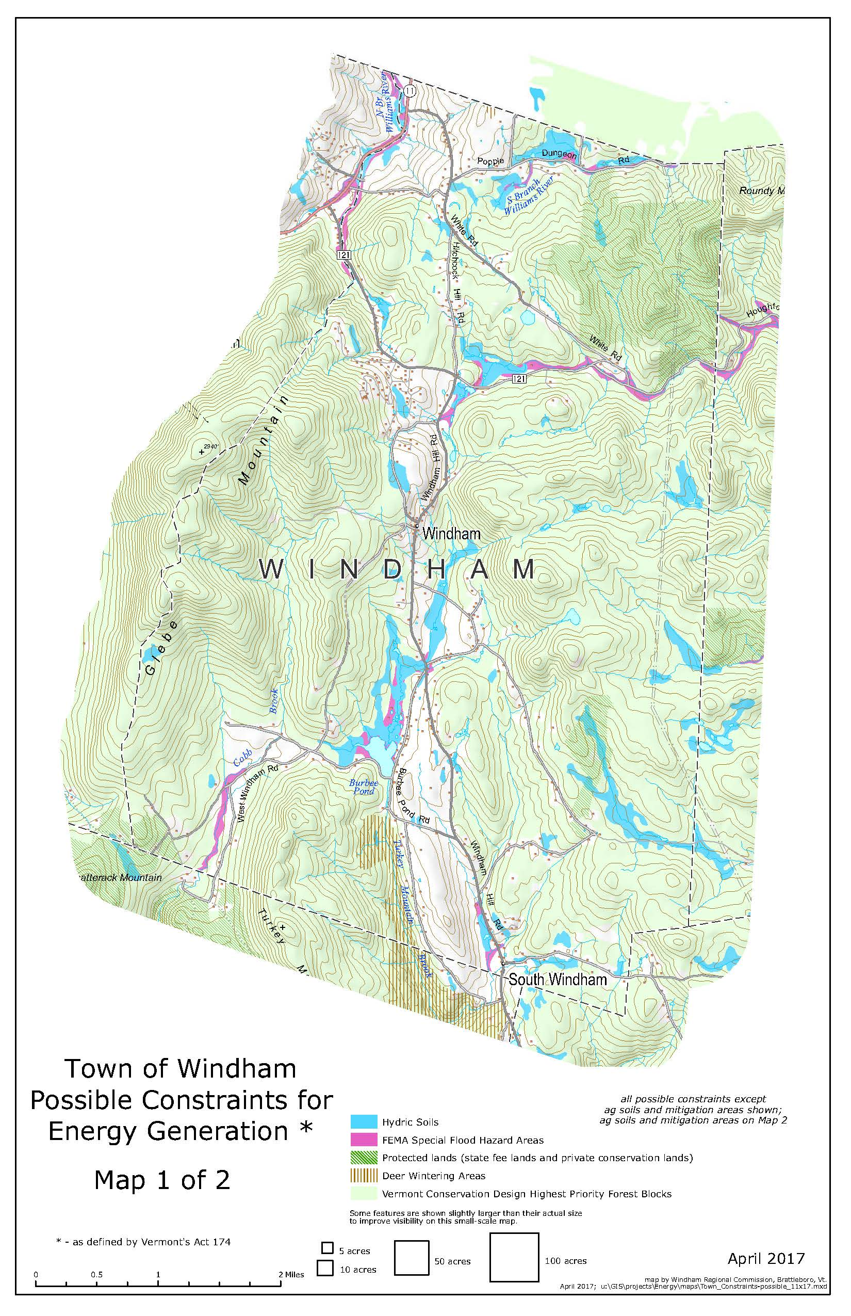
Map 1
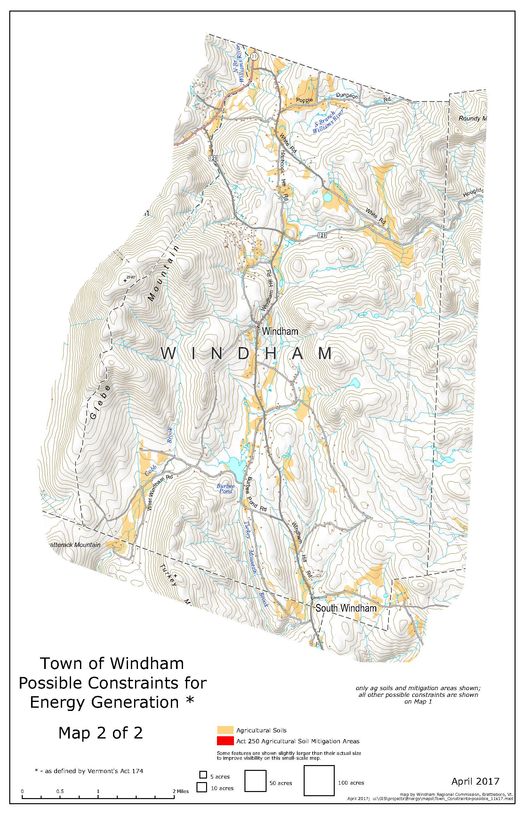
Map 2
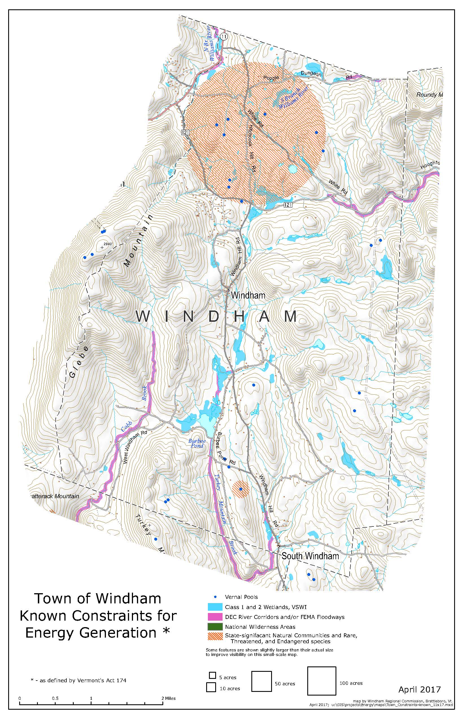
Map 3
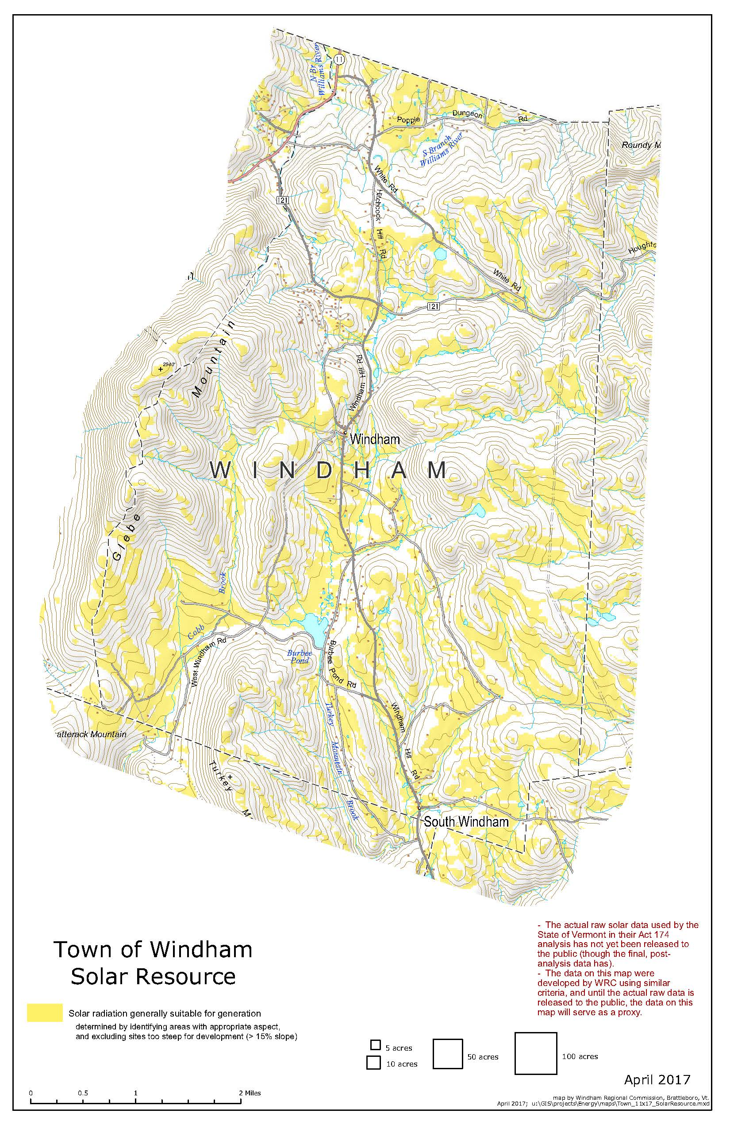
Map 4
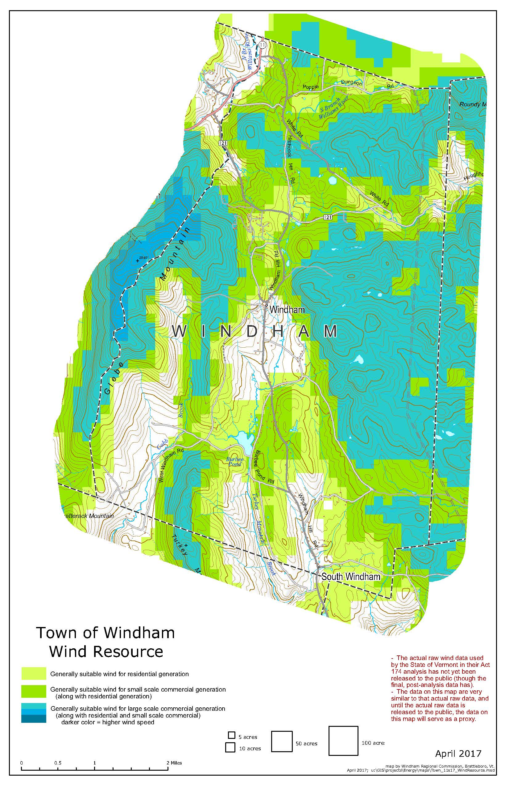
Map 5
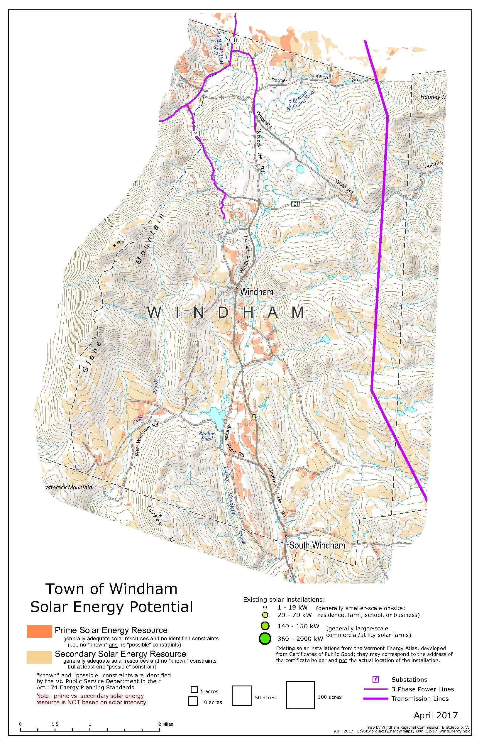
Map 6
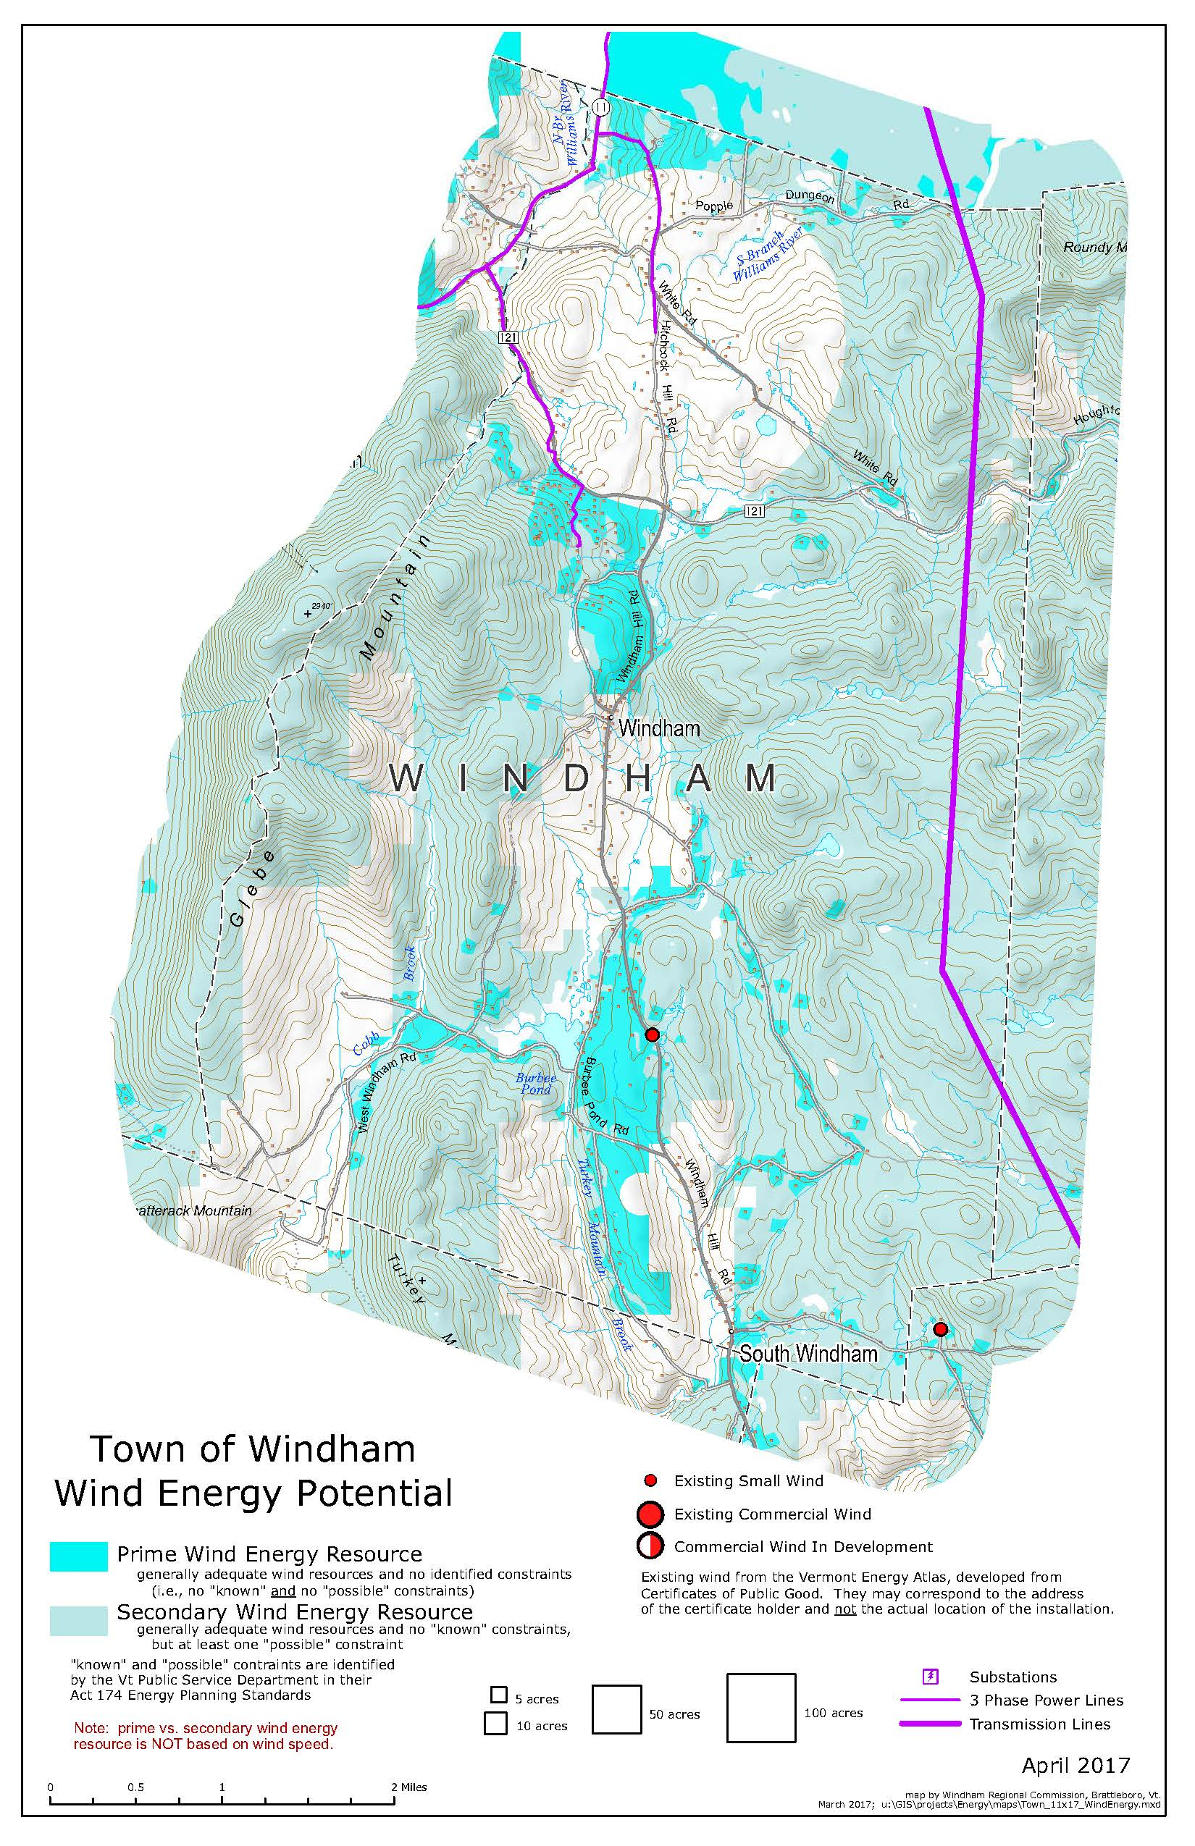
Map 7
Map 8
Map 9

