Drafty Windows? We can help!
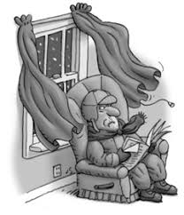
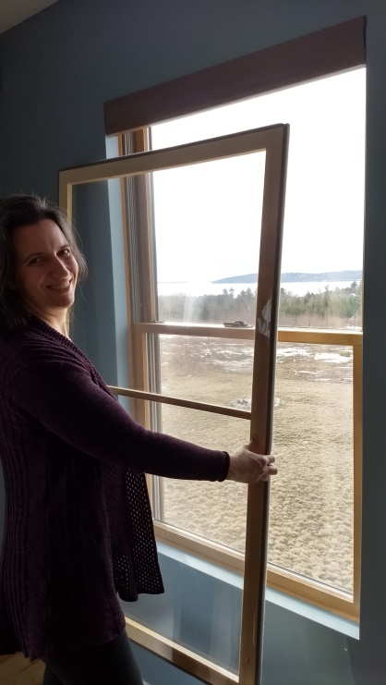

Low-Cost Insulating Window Inserts by a Maine NonProfit
Custom-built to fit your home’s windows.
Volunteer-Made at your Local Community Build in _________________
Call ____________________________ at _________________________
for more information and to sign up for inserts.
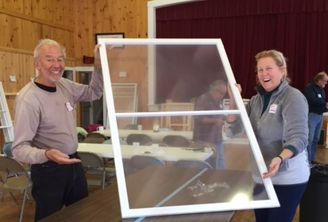

Warming Homes – Helping the Environment – Building Community

