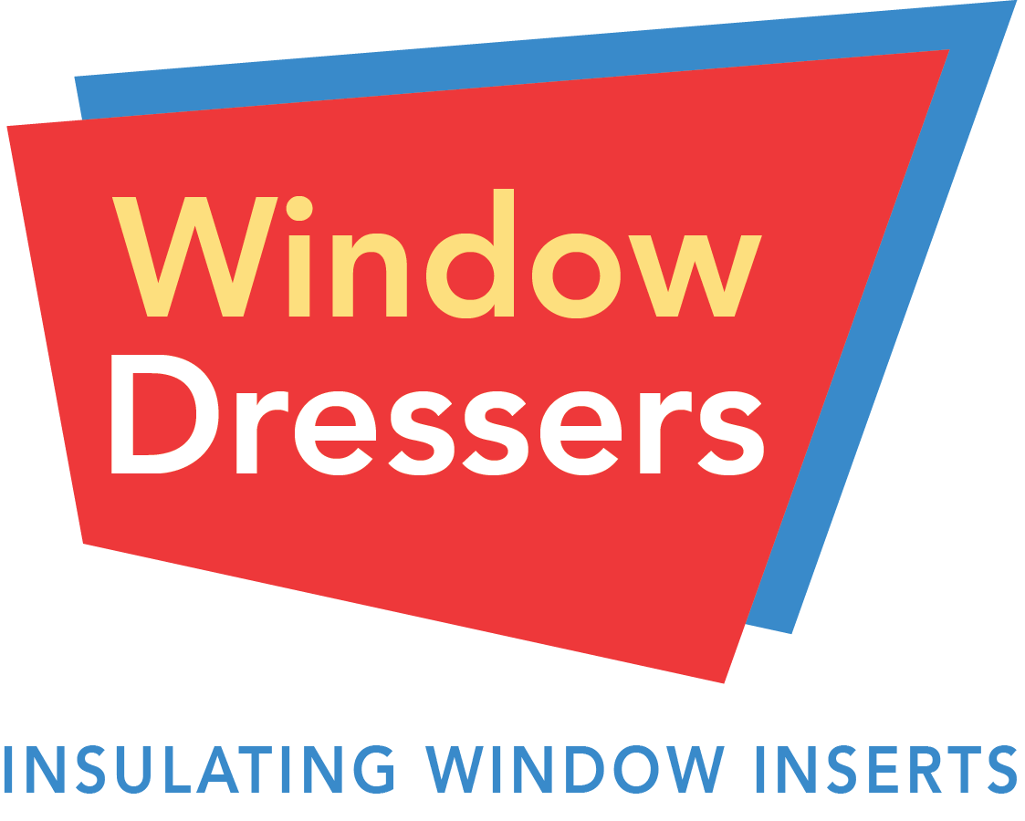
Sign Up to Get Low Cost WindowDressers Insulating Window Inserts Today!

Date of 2022 Wardsboro/Londonderry/Windham build:
November 11 – 16, 2022
Location: Windham Meeting House in Windham, VT

WindowDressers is a grassroots, volunteer-run, nonprofit organization that brings community volunteers of all economic and social situations together to improve the warmth and comfort of interior spaces, lower heating costs, and reduce carbon dioxide pollution by producing low-cost insulating window inserts that function as custom, interior-mounted storm windows.

2021 Build Testimonials

"These inserts made it possible for my family of 6 to use our bedrooms in the upstairs of our 1805 house which we hadn't been able to do the year before. The inserts are life changing" - Catherine Marrow, Windham

"Last year’s inserts from the Window Dressers build were very effective. They prevented cold drafts in our circa 1830 home and made a difference in the heating costs." - Marilyn LaBarr, Wardsboro.

“All of the church windows were measured and we were able to participate and help at the community build in Windham, Vermont. The Window Dressers inserts made such a difference during the winter months. It was much warmer in the sanctuary and therefore, helped us conserve heat and save on our fuel costs.” - Wardsboro Methodist Church Trustees, Wardsboro

Our Cooperative Build Model: Building Inserts = Building Community
We keep our insert-prices exceptionally low through our non-profit model of cooperative insert-building. After signing up for inserts, trained volunteers will make a house-call to measure your windows.
- Your participation at the Community Build where your inserts are made is an expected part of the cost of inserts.
- Community Builds are fun events and they foster a spirit of volunteerism, participation and connection. All are welcome!
Pricing and Payment
You will receive the exact price of your inserts based on the measurements of your windows at the end of the measuring visit. Payment is due at the time of the measuring visit.
If you have limited income or are experiencing financial difficulty, please ask your Measuring Team about our Special Rate pricing program, where we offer up to 10 inserts per season for no cost. Donations to support our Special Rate program are always welcome.
Our inserts are custom built to the exact measurements of your windows. Your exact price will vary. A medium: 30” x 52” insert costs $44.50. For a full price chart please visit windowdressers.org.

To sign up for inserts please email wardsboroenergycommitte@gmail.com or you can order inserts directly at windowdressers.org/sign-up-for-inserts!

